International Seminar on -
“Recent Advances in Molecules and Materials (RA2M-2018)”

In commemoration of the 157th Anniversary of
Acharya Prafulla Chandra Ray

August 02 & 03, 2018

Organised by
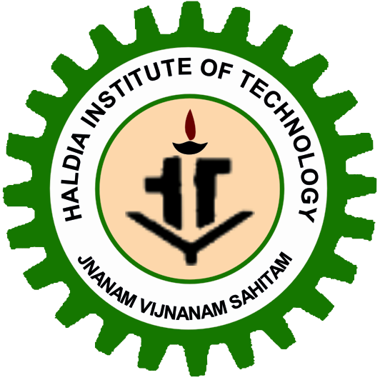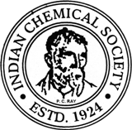
School of Applied Science and Humanities
Haldia Institute of Technology, Haldia-721657, West Bengal, India
&
The Indian Chemical Society
92, Acharya Prafulla Chandra Road
Kolkata 700 009

International Conference on - “Recent Advances in Molecules and Materials (RA2M-2018)” on 2-3 August, 2018
INTERNATIONAL ADVISORY BODY
Chief Patron: Dr. Lakshman Seth, Chiarman HIT (Ex. Member of Parliament)
Patron : Prof. M.N. Bondopadhyay, Ditector, HIT
Sri Asish Lahiri
Prof. D. C. Mukherjee, Honorary President, Indian Chemical Society
Prof. Sonali Chakravarti Banerjee, Vice-Chancellor, Calcutta University
Prof. Ranjan Chakrabari, Vice-Chancellor, Vidyasagar University
Prof. Partha Pratim Chakrabarti, Director, Indian Institute of Technology, Kharagpur
Prof. Saikat Maitra, Vice-Chancellor, Maulana Abul Kalam Azad University of Technology
Prof. S. K. Talapatra, Sr. Advisor, Indian Chemical Society
Prof. Bani Talapatra, EC Member, Indian Chemical Society
Prof. Animesh Rakshit, EC Member, Indian Chemical Society
Prof. Ebbe Nordlander, Lund University, Sweden
Prof. Takashiro Akitsu, Tokyo University of Science, Japan
Dr. Anil Kumar , NCL, Pune
Prof. Samaresh Bhattacharya, Jadavpur University, Kolkata
Prof. Akhilesh Verma, Delhi University, New Delhi,
Prof. Pradeep Kumar Sharma, J N V University, Jodhpur, Rajasthan.
Prof. Bimal K Banik, USA
Prof. Christopher W. Bielawski, Republic of Korea
Prof. J. J. Vittal, NUS, Singapore
Dr. Samar Roychowdhury, NCCS, Pune
Prof. R. N. Prasad, Advisor, Indian Chemical Society
Prof. Mahesh Chattopadhyay, Advisor, Indian Chemical Society
Prof. S. C. Ameta, Advisor, Indian Chemical Society
Prof. P. L. Majumder, Former Honorary Secretary, Indian Chemical Society
Prof. S. T. Nandibewoor, EC Member, ICS, Southern Zone
Dr. D. V. Prabhu, General Secretary, ACT
Prof. Ashutosh Ghosh, Former Vice-Chancellor, Calcutta University
Prof. Sheo Satya Prakash, Vice-President, Indian Chemical Society
Prof. Anshu Dandia, EC Member (Northern Zone), Indian Chemical Society
Prof. Subhas Chandra Bhattacharya, Jadavpur University
Prof. Samita Basu, Saha Institute of Nuclear Physics, Kolkata

International Symposium Committee
Prof. Chittaranjan Sinha, Honorary Secretary, Indian Chemical Society & Convener of the Symposium
Prof. Sudip Das, Honorary Treasurer, Indian Chemical Society
Dr. Gouri Sankar Roymahapatra, Convener, RA2M-2018,HIT
Dr. Sibaprasad Maity, Treasurer RA2M-2018,HIT
Prof. Jayati Datta, EC Member (HQ) & Asst. Secretary, Indian Chemical Society
Prof. Ashok Kumar Jha, EC Member (Eastern Zone), Indian Chemical Society
Prof. E. Sukumar, EC Member (Souther Zone), Indian Chemical Society
Prof. Ashu Rani, University of Kota
Prof. Anand Aswar, SGB University, Amravati
Prof. Binay K Ghorai, IIEST, Shibpur
Prof. Susanta K. Lahiri, SINP, Kolkata
Dr. Biswajit Pal, St-Paul’s Cathedral College
Dr. Kamalika Sen, C. U., Editor, ECST
Dr. (Mrs.) Suvroma Gupta, Biotechnology, HIT
Dr. Soumitra Deb, Advisor, East India Pharmaceutical Co., Kolkata
Dr. Jaydeb Dinda, Utkal University, Odisha
Prof. R. C. Deka, Tezpur University, Assam
Dr. M. G. Dhonde, EC Member (Western Zone), Indian Chemical Society
Dr. Jagatpati Tah, Ex-Burdwan University
Mr. Roshan Yadav, Executive Director, Inst. Biotech. Environment Development, Kathmandu, Nepal

Local Organizing Committee

Secretary: Dr. Gourisankar Roymahapatra
Joint Secretary:
Treasurer:

Convenors Technical Committee:

Convenors Refreshment Committee:
Convenors Reception Committee:
Convenors Chemistry for better tomorrow (School Children Competition):

